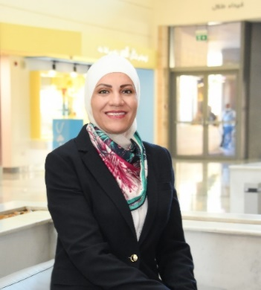
Presentation title: Innovative approaches in Cancer Prevention
Corresponding Author name: Ms. Nisreen Qatamish
Affiliation: King Hussein Cancer Foundation (KHCF)
Ph. No: 00962795449988
Email ID’s: nisreen.qatamish@khcf.jo
WhatsApp No: 00962795449988
Any alternative number: 00962795802119
Twitter: @nisreenqatamish
LinkedIn: linkedin.com/in/Nisreen-qatamish-67882a1b
Facebook: https://www.facebook.com/nisreen.qatamish.5/
Other Authors if any: Ms. Rozan Musharbash
Presentation type: Oral presentation
Abstract (250-300 words):
King Hussein Cancer Foundation (KHCF) is the largest community-based organization fully dedicated to combating cancer. Our vision is to save lives by engaging society in the fight against cancer in Jordan and the region and to promote the highest standards of comprehensive cancer care and control. KHCF’s mission is to fight all modifiable risk factors associated with cancer such as tobacco use, physical inactivity, unhealthy diet, and air pollution while enhancing the use and provision of early detection tests.
KHCF has a rich body of experience accumulated over the past several years in social behavior change communication and public mobilization and engagement of both individuals and resources toward cancer prevention. KHCF’s successes in these areas has been the motive behind the “Jordan against Cancer” program which was designed to highlight the impact of leading a healthy lifestyle in cancer prevention and engages and encourages the local community and transforms them into advocates in the fight against cancer as this is a collective responsibility and does not lay only in the hands of cancer organizations.
“Jordan against Cancer” targets private corporates, CBO’s, NGO’s, schools and governmental entities and utilizes both mass media and digital media to reach a wide audience highlighting the campaign’s messages of cancer prevention. The program incorporates several campaigns including “Go Green against Cancer” which increases awareness about environmental risk factors and their relation to cancer. During 2023 alone, a total of 954 educational sessions were conducted reaching a total of 30,227 individuals and more than 5 million impressions on social media.
This year, KHCF aims to reach an even wider audience in hopes to increase awareness about cancer prevention and hopefully decrease the number of new cancers diagnoses each year.

Biography (150-200 words):
As a leader in the development sectors, Nisreen Qatamish was appointed in 2016 as Director General of the King Hussein Cancer Foundation (KHCF), the largest community-based organization in Jordan dedicated to combating cancer. In this role, she is responsible for overseeing KHCF’s fundraising and development efforts, driving global advocacy programs, raising public awareness on early detection and prevention, as well as cancer coverage and patient support. Ms. Qatamish currently serves as a board member in Jordan Breast Cancer Program (JBCP) Board of Directors, and National Medical Tourism Board of Trustees, among other national platforms. Qatamish’s experience is well recognized on both a national and regional level. She is also a prominent consultant and trainer in various sectors, with special focus on capacity building within the healthcare industry, advocacy and change management. Qatamish is further known as a leading promoter and advocate for gender equality, and cancer prevention and early detection.

