Presentation title: Infiltrating (Intramuscular) Angiolipoma of the Foot in a Pediatric Filipino Patient: A Rare Case Study Assessing Clinical, Imaging, and Surgical Findings  Corresponding Author name: Sushmica Cumigad Baquiran, MD  Affiliation: East Avenue Medical Center  Ph. No: (+63) 917 722 8687  Email ID’s: sushmicab@gmail.com  WhatsApp No: +63 917 722 8687  Any alternative number:  Twitter: @misssushimi  Presentation type: (Poster presentation) | 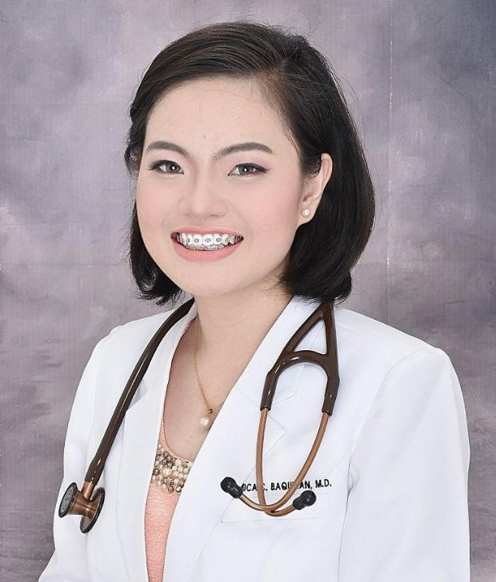
Abstract (250-300 words):
Angiolipomas, characterized by mature adipose tissue intermixed with small vessels, are rare benign tumors that are most commonly found in the extremities and typically manifesting between the second and third decades of life. Here, we report a unique case of Infiltrating (Intramuscular) angiolipoma in a 3-year-old Filipino boy with a foot mass, highlighting the rarity of this presentation among Filipino children and the unusual location in the foot. The discussion delves into the histological and radiological features, the differential diagnosis, and treatment modalities, with surgical excision being the primary approach. In conclusion, recognizing this entity, especially in atypical locations and patient demographics, is crucial for accurate diagnosis and management, adding valuable insights to existing literature. Surgical excision offers favorable outcomes, emphasizing the importance of meticulous technique in achieving complete tumor removal. Histological confirmation is essential, along with long-term follow-up to monitor for recurrence. This case underscores the need for continued vigilance in recognizing and managing rare soft tissue tumors, ensuring optimal patient care and outcomes among our patients.

Biography (150-200 words):
Sushmica Cumigad Baquiran, MD, is a 29-year-old female from the Philippines currently in her 3rd year of Orthopedic residency training. Working as an Orthopedic surgeon in a tertiary Government center, she deals with a spectrum of cases ranging from trauma, infections, to tumors, catering to both adult and pediatric patients. Driven by a passion for healing, she embodies a well-rounded approach, blending clinical expertise with surgical finesse. With a keen eye for assessment and examination, Dr. Baquiran crafts tailored treatment plans that target not only symptoms but also the root causes of various conditions. Her dedication to staying abreast of the latest medical advancements ensures that her patients receive cutting-edge care. Known for her respectful demeanor and holistic outlook, she is a reliable healthcare provider committed to delivering quality and safe medical interventions to patients with diverse needs. In every encounter, Dr. Baquiran's commitment shines through, making her a beacon of hope and healing in the medical community in the Philippines.

