Presentation title: Assessment of Knowledge, Attitude & Practice of Medical oncologists regarding Chemotherapy induced nausea & vomiting (CINV) in IRAN
Corresponding Author name: Amir Hossein Emami
Affiliation :Professor of medical oncology & hematology at Tehran university of medical sciences (TUMS)
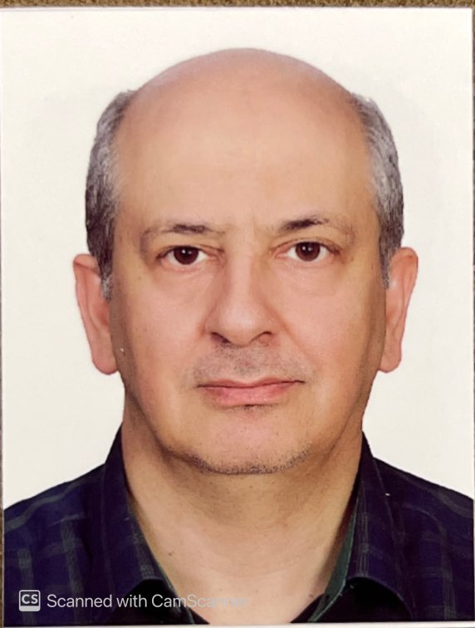
Ph.No:+989121063743
Email ID:emamiami@yahoo.com/ emamiami@tums.ac.ir
Other Authors: Ali Majidinejad . Aeen Mohammadi . Zahra jahangard Rafsanjani . Reza safaee . Maryam taghizadeh ghohi . Ahmad khajeh mehrizi
Presentation type : poster presentation

In this cross- sectional study, a researcher-made questionnaire was used to evaluate the knowledge, attitude and practice (KAP) of Iranian medical oncologists regarding chemotherapy induced nausea and vomiting (CINV).
A total of 131 medical oncologists were asked to fill out the questionnaire, and 105 of them completed it, resulting in an 80% response rate. Out of the participants, 78 (74%) were male. The knowledge score of the participants was 17, and the attitude score was 2, both of which were graded as favorable in our study.
The NCCN guideline was the most commonly used guideline (69%). The professional service score and age of physicians did not significantly affect the KAP score. However, male physicians had a significantly higher knowledge score than females. Despite the use of guidelines, 41% of physicians reported that their patients still experienced CINV. The majority of physicians (84%) believed that non-compliance with reliable guidelines is a major reason for failure in preventing CINV. Additionally, 73% of physicians believed that the emetogenic potential of chemotherapy regimens is underestimated and 78% believed that underlying anxiety and depression in patients aggravate CINV.
Conclusion :This study demonstrated favorable level of knowledge ,attitude and practice of Iranian medical oncologists regarding CINV. Meanwhile attention to compliance and also mood of patients is important in controlling CINV.

