Presentation title: Analyzing Fruit Fly Mortality Rates with Tobacco Extract-Enriched Diets
Corresponding Author name: Yihao Huang
Affiliation: Division of Biology, CIE Department, Guangdong Country Garden School, Guangdong Province, China
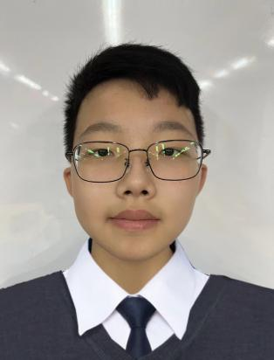
Ph. No: 086-15587111512
Email ID’s: saber_a14@yahoo.com
WhatsApp No: No
Any alternative number: 086-13630021864
Twitter: No
LinkedIn: No
Facebook: No
Other Authors if any: Xiyue Shao, Xiaotong Tan, Rufei Ma, Joanna Louise Dykins, Qihao Liang, Saber Khederzadeh
Presentation type: Virtual presentation

Abstract (250-300 words):
Nicotine, a primary toxin in tobacco, affects Drosophila's nervous system, altering behavior and physiology. Additionally, exposure leads to reduced fecundity and delayed development. Tobacco's other harmful compounds, like polycyclic aromatic hydrocarbons (PAHs) and heavy metals, are mutagenic and carcinogenic, posing risks of DNA damage and genetic mutations. In this study, we explored the detrimental impacts of all elements present in tobacco extract on the mortality and hatching rates of fruit flies in pupa and adult stage based on varied tobacco extract-enriched diets. Our monitoring during the parental generation indicated a minimal mortality rate, suggesting that tobacco extract does not exert a significant immediate impact on the health of the parent generation through dietary intake over a short duration (mortality rate of 0~2 flies). However, in the subsequent generations (F1/F2), the consumption of the lowest concentration of tobacco extract-enriched diets resulted in an increased population size (high hatching rate with no mortality) in the control group. Conversely, the highest concentration of tobacco extract exhibited the lowest hatching rate and the highest mortality rate. The implications of our study contribute to a broader comprehension of potential risks and mechanisms of diseases associated with tobacco exposure in humans.

Biography (150-200 words):
Yihao Huang, with an unwavering passion for improving health and wellbeing, he has become a trailblazer in the field of biology, leaving an indelible mark through groundbreaking contributions. His work with his team members (Xiyue Shao, Xiaotong Tan, Rufei Ma, Joanna Louise Dykins, Qihao Liang) is bridging the gap between environmental factors and physiological responses which leads to cancer in diverse species. His commitment to unraveling the intricacies of this complex interaction underscores a profound dedication to understanding the broader implications for both animal and human health.

