Presentation title: Analyzing Fruit Fly Mortality Rates with Tobacco Extract-Enriched Diets
Corresponding Author name: Saber Khederzadeh
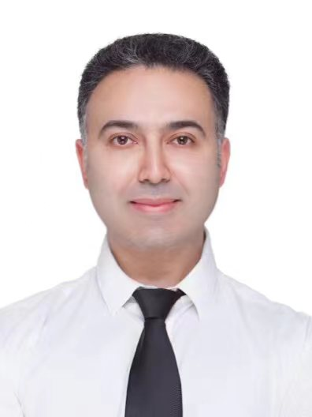
Affiliation: Institute of Basic Medical Sciences, Westlake Institute for Advanced Study, 18 Shilongshan Road, Hangzhou, Zhejiang 310024, China
Ph. No: 086-15587111512
Email ID’s: saber_a14@yahoo.com
WhatsApp No: No
Any alternative number: 086-13630021864
Twitter: No
LinkedIn: No
Facebook: No
Other Authors if any: Yihao Huang, Xiyue Shao, Xiaotong Tan, Rufei Ma, Joanna Louise Dykins, Qihao Liang, Saber Khederzadeh
Presentation type: Oral presentation

Abstract (250-300 words):
Nicotine, a primary toxin in tobacco, affects Drosophila's nervous system, altering behavior and physiology. Additionally, exposure leads to reduced fecundity and delayed development. Tobacco's other harmful compounds, like polycyclic aromatic hydrocarbons (PAHs) and heavy metals, are mutagenic and carcinogenic, posing risks of DNA damage and genetic mutations. In this study, we explored the detrimental impacts of all elements present in tobacco extract on the mortality and hatching rates of fruit flies in pupa and adult stage based on varied tobacco extract-enriched diets. Our monitoring during the parental generation indicated a minimal mortality rate, suggesting that tobacco extract does not exert a significant immediate impact on the health of the parent generation through dietary intake over a short duration (mortality rate of 0~2 flies). However, in the subsequent generations (F1/F2), the consumption of the lowest concentration of tobacco extract-enriched diets resulted in an increased population size (high hatching rate with no mortality) in the control group. Conversely, the highest concentration of tobacco extract exhibited the lowest hatching rate and the highest mortality rate. The implications of our study contribute to a broader comprehension of potential risks and mechanisms of diseases associated with tobacco exposure in humans.

Biography (150-200 words):
Dr. Saber Khederzadeh, a luminary in the realm of genomic and medical sciences, is a dedicated professional whose expertise is transforming the landscape of healthcare. With an unwavering passion for improving health and wellbeing, he has become a trailblazer in the field, leaving an indelible mark through groundbreaking contributions. His prolific academic journey is punctuated by several impactful publications, showcasing a commitment to advancing knowledge in genomics. His work goes beyond the conventional boundaries, merging cutting-edge research with a compassionate drive to enhance lives. As a visionary in genomic and medical sciences, Dr. Saber Khederzadeh exemplifies the intersection of intellect, innovation, and empathy, driving positive change in the pursuit of a healthier world. He is delving into the intricate relationship between harmful components and various animal models. Focused on elucidating the effects of these substances, his work stands at the forefront of scientific inquiry, bridging the gap between environmental factors and physiological responses which leads to cancer in diverse species. His commitment to unraveling the intricacies of this complex interaction underscores a profound dedication to understanding the broader implications for both animal and human health.

