Sample Abstract Guidelines:

- Abstract Content should be in English
- The maximum word count should be 250-300 words
- If your title includes scientific notation, Greek letters, bold, italics, or other special characters/symbols, do make sure they appear correctly.
- Corresponding details of corresponding author should be correct which will be used for further communication.
- Abstracts should highlight the major points of your research and should not include tables, figures and references.
Format

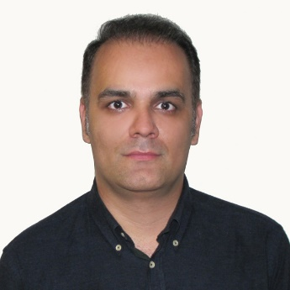Presentation title: Novel molecular insights and new therapeutic strategies in osteosarcoma

Corresponding Author name: Babak Otoukesh
Affiliation: Iran University of Medical Sciences
Ph. No: +989126843678
Email ID’s: Babak.otoukesh@hotmail.com
WhatsApp No: +989126843678
Any alternative number:
Twitter:
LinkedIn: BABAK OTOUKESH
Facebook:
Other Authors if any:
Presentation type: (Oral presentation/ Poster presentation) Oral Presentation
Abstract (250-300 words):
Osteosarcoma (OS) is one of the most prevalent malignant cancers with lower survival and poor overall prognosis mainly in children and adolescents. Identifying the molecular mechanisms and OS stem cells (OSCs) as new concepts involved in disease pathogenesis and progression may potentially lead to new therapeutic targets. Therefore, therapeutic targeting of OSCs can be one of the most important and effective strategies for the treatment of OS. This review describes the new molecular targets of OS as well as novel therapeutic approaches in the design of future investigations and treatment.
Biography (150-200 words):
I am an orthopedic surgeon specializing in tumor and ankle surgery, and I am currently working at Hazrat Rasool Akram Hospital affiliated to Iran University of Medical Sciences, my research field is finding new methods in the treatment of bone tumors with the aim of increasing the quality of life of the patients and a significant reduction in treatment costs and surgical complications and prevention of limb amputation. My research works have more than 300 citations from all over the world.

