Sample Abstract Guidelines:

- Abstract Content should be in English
- The maximum word count should be 250-300 words
- If your title includes scientific notation, Greek letters, bold, italics, or other special characters/symbols, do make sure they appear correctly.
- Corresponding details of corresponding author should be correct which will be used for further communication.
- Abstracts should highlight the major points of your research and should not include tables, figures and references.
Format

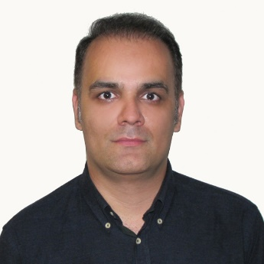Presentation title: MicroRNAs signatures, bioinformatics analysis of miRNAs, miRNA mimics and antagonists, and miRNA therapeutics in osteosarcoma

Corresponding Author name: Babak Otoukesh
Affiliation: Iran University of Medical Sciences
Ph. No: +989126843678
Email ID’s: Babak.otoukesh@hotmail.com
WhatsApp No: +989126843678
Any alternative number:
Twitter:
LinkedIn: BABAK OTOUKESH
Facebook:
Other Authors if any:
Presentation type: (Oral presentation/ Poster presentation) Oral Presentation
Abstract (250-300 words):
MicroRNAs (miRNAs) involved in key signaling pathways and aggressive phenotypes of osteosarcoma (OS) was discussed, including PI3K/AKT/MTOR, MTOR AND RAF-1 signaling, tumor suppressor P53- linked miRNAs, NOTCH- related miRNAs, miRNA -15/16 cluster, apoptosis related miRNAs, invasion-metastasis-related miRNAs, and 14Q32-associated miRNAs cluster. Herrin, we discussed insights into the targeted therapies including miRNAs (i.e., tumor-suppressive miRNAs and oncomiRNAs). Using bioinformatics tools, the interaction network of all OS-associated miRNAs and their targets was also depicted.

Biography (150-200 words):
I am an orthopedic surgeon specializing in tumor and ankle surgery, and I am currently working at Hazrat Rasool Akram Hospital affiliated to Iran University of Medical Sciences, my research field is finding new methods in the treatment of bone tumors with the aim of increasing the quality of life of the patients and a significant reduction in treatment costs and surgical complications and prevention of limb amputation. My research works have more than 300 citations from all over the world.

