Presentation title: Role of “MANLATA model” in predicting recurrence in patients with Hepatocellular carcinoma undergoing Trans Arterial Chemo-embolization

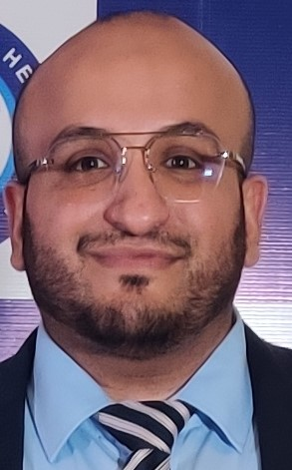
Corresponding Author name: Dr. Raja Taha Yaseen Khan
Affiliation: Consultant Gastroenterologist and Hepatologist
Sindh Institute of Urology and Transplantation,Pakistan
Ph. No: 0092-3042613720
Email ID: raja_taha101488@hotmail.com
WhatsApp No: 0092-3312812391
Twitter: raja_taha101488@hotmail.com
Facebook: Raja Taha Yaseen Khan (raja_taha101488@hotail.com)
Presentation type: Oral presentation

Abstract
Introduction:
Hepatocellular carcinoma (HCC) represents the sixth most common neoplasm in terms of incidence and the third leading cause of cancer death. Unfortunately, most of patients with HCC are diagnosed at an advanced stage and are treated by the palliative options. Trans-arterial chemoembolization (TACE) is the best therapeutic option in this situation. Our aim was to identify the non-invasive predictive factors and to build a model using these predictors suggestive of post TACE recurrence of HCC .
Methods:
It was a retrospective study which included all the patients aged 18-65 years with HCC undergoing TACE from January 2010 to December 2018.While, the patients with early stage HCC undergoing resection, advanced staged HCC bearing portal vein thrombosis, metastatic HCC, patients with poor ECOG status and advanced child class were excluded. Univariate and multivariate logistic regression analysis was performed to identify the independent predictors of post TACE recurrence. A model was then developed for which AUROC was obtained and at an optimal cutoff, the diagnostic accuracy of the model was obtained.
Results:
A total of 323 patients were included in the study. Among them,281(87%) were males. Baseline characteristics of all patients undergoing TACE were recorded. On multivariate analysis,male gender,age > 50 years ,tumor size > 5cm, serum albumin <2.8 g/dl , serum alphafetoprotein > 300 ng/ml, neutrophil count >60 % and lymphocyte count <25% were independent predictors of post TACE recurrence. Using these variables, a model “MANLATA model” was developed which had an AUROC of (0.976) and at a cutoff >7 , it had an excellent sensitivity of 98%, specificity of 86.8% and diagnostic accuracy of 93% in predicting post TACE recurrence.
Conclusion:
The non-invasive model had an excellent diagnostic accuracy in predicting post TACE recurrence.However, further studies comprising of large sample sizes are required to validate this model.
Keywords: TACE, HCC recurrence, non-invasive model

Biography
Dr. Raja Taha Yaseen Khan is currently working as a consultant Gastroenterologist and Hepatologist at the Department of Hepato-gastroenterology, SIUT with special interest in hepatobiliary diseases and the utility of the advanced endoscopic modalities in the diagnosis and the management of these diseases. He also has a special interest in research and has over more than 70 papers published in various peer reviewed journals around the globe. His research work is mainly focused on the non-invasive models predicting liver fibrosis, presence of CBD stone, post ERCP cholangitis and HCC recurrence after TACE. He received applause both at national and international level for the proposition of multiple models “AGT” and “BATS” score in predicting CBD stone, “MANLATA model” in predicting post TACE recurrence and as a coauthor in “HinCh” score in predicting cholangitis after endoscopic intervention along with his work on gall bladder cancer. His latest ongoing research is mainly focused on hepatitis B and its demographics in the hemodialysis population.

