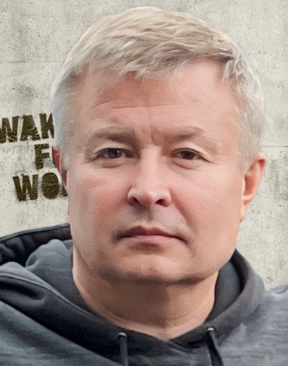
Presentation title: Efficiency of nanoparticles (Micromage-B) in the complex treatment of multiple sclerosis
Corresponding Author name: Andrey Belousov
Affiliation: Laboratory of Applied Nanotechnology of Belousov, Kharkiv National Medical University, Kharkiv, Ukraine
Ph. No: +380-50-915-18-89
Email ID’s: an.belousov2012@ukr.net
WhatsApp No: +380-50-915-18-89
Any alternative number: +380-50-915-18-89
Other Authors if any: E.Yu. Belousova, A.V. Mysik
Presentation type: Video presentation
Multiple sclerosis (MS) is a serious neurological problem because of its high prevalence, chronic course, frequent disability, and propensity to affect young people. The immunopathogenesis hypothesis underlies the origin of MS. Selective sorption activity of biocompatible magnetite nanoparticles against surface proteins of cell membranes, circulating immune complexes, lymphocytotoxic antibodies, complement system, the effect of increasing phagocytic activity and leukocyte phagocytosis completion index allows the effective use of these nanodevices for immunocorrection. The main goal of the study is to slow down the progression of MS, improve the neurological status and general condition of the patient, and reduce the dynamics of the spread of demyelinating foci in the brain. Materials and methods: a patient diagnosed with multiple sclerosis, secondary progressive type of course, cerebro-spinal form, clinical aggravation stage; EDSS neurological status and disability assessment scales; contrast-enhanced MRI of the brain. An oral form of the nanodevice Micromage-B was used as an immunosorbent and immunomodulator. The choice of the regimen and dosage of Micromage-B was personalized. Assessment of the general condition and neurological status was performed every 7 days for 6 months. Contrast-enhanced MRI of the brain was performed at the 5th month of the study. As a result of using Micromage-B in MS treatment, objective improvement of neurological status, reduction of stiffness and rapid fatigability of the lower extremities were observed. Gait and coordination improved, hand tremors decreased, depression and signs of concentration disorders disappeared, appetite restored, and speech improved. During the entire period of Micromage-B application, positive dynamics in the normalization of the neurological status was observed. After 6 months of treatment, the total score dropped by 210 to 45. It was found that the maximum positive effect was observed in the evaluation of the pyramidal system and coordination. The EDSS Disability Scale score decreased from 6.0 to 5.0. Contrast-enhanced MRI brain examination for the first time showed a decrease in the number of new foci of demyelination in the brain by the 4th month of Micromage-B administration. The positive dynamics of normalization of the neurological status correlated with the results of brain MRI. The process of recovery of central nervous system activity in MS is not only due to the immunosuppressive properties of magnetite nanoparticles, but is probably caused by the activation of remyelination mechanisms and oligodendrocyte differentiation through enzymatic methylation. Considering the above, the use of biocompatible nanodevices in the complex treatment of MS is a promising direction. The scheme and method of using biocompatible magnetite nanoparticles to improve the effectiveness of MS treatment require further improvement and study.
Biography:
Andrey Nikolaevych Belousov is Doctor of Medicine degree on speciality - Anesthesiology and Intensive Care. Author a new medicine products – nanotechnology preparations based on magnetite nanoparticles (Fe₃O₄) (www.nanolab.com.ua): Micromage-B (officially registration in Ukraine); Magnet-controlled sorbent brand of MCS-B for extracorporeal detoxication of biological liquids (officially registration in Ukraine and was allowed for medical practice); NanoBiocorrector for intravenous application – ICNB (intracorporal nanosorbent). A.N. Belousov is author new method of extracorporeal hemocorrection using magnet-controlled sorbent (MCS-B). The published more 290 scientific works on results application of nanotechnology preparation in experimental and practical medicine. At now Andrey Belousov - the Head of Laboratory Applied Nanotechnologies in Ukraine, DM, Professor of Kharkiv National Medical University, Ukraine.

