Format

Study of the rheological and rheokinetic behaviour of a sulfonated polystyrene system during the curing process

Corresponding Author name Mohammed el amine ZENNAKI
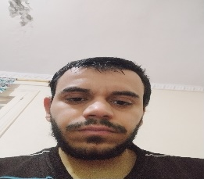
Affiliation: Laboratory of Organic Electrolytes and Polyelectrolytes Application (LAEPO). Department of Chemistry, Faculty of Sciences, Tlemcen University, Algeria
Ph. No: +213-556883432
Email ID’s: zenamine12@gmail.com
WhatsApp No: For conference updates+213-556883432
Other Authors if any: Oussama BOURAS, Oussama AMMOUR , Lahcene TENNOUGA, Brahim BOURAS
Presentation type: (Oral presentation) : Oral

Abstract
In this work, we have focused on the recycling of waste expanded polystyrene, which allows us to obtain a new copolymer based on polystyrene. The properties of the obtained copolymer as well as its structure and composition were established by UV-visible, FTIR spectroscopy and TGA analysis. The curing and compaction of the system was studied by dynamic rheology. A rheometer was used to monitor changes in rheological parameters (storage modulus G', loss modulus G", dynamic viscosity η*) during continuous heating, isothermal ageing and high frequency heat treatment. The results showed that the combination of isothermal ageing, heating and high frequency was a simple strategy for low-temperature curing or shortening the curing time of complex.

