Presentation title: Ilmenite reduction kinetics extracted from carbonitrothermic reduction simulation.
Corresponding Author name: Refilwe Jenifer Motsoeri
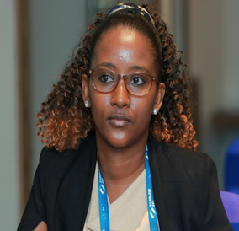
Affiliation: University of Johannesburg
Phone no: 078 6303 217
Email: Refilwekunatu@gmail.com
Presentation: Oral presentation
South African Ilmenite ore processing
The present process environment, especially in science and technology, requires high temperature processing to extract and purify metals; various thermodynamics studies need expansion for process optimization purposes. The focus on thermodynamical calculations and reduction kinetics to predict material's behavior under different temperatures and studying phase transformation to verify reactions occurring during the process is of importance. The subject of South African Ilmenite processing and meeting the standards of demand for material science applications requires improvement. The decarbonization era is an eye opened to implement new strategies of exploring options for innovation and sustainability purposes. The market for titanium ore is expanding yearly and all sources of the metal require attention to be processed. Tailing dams require better technology for exploring locked and other source carriers for titanium ore. Smelting processes require expansion specifically for technical aspects to manipulate reduction parameters and improve process chemistry to maintain customers needs.
Mineralogical aspects of the orebody require deep understanding and scope expansion to be able to study reaction kinetics for different sources of titanium mineral. Data generation for quantification of isothermal structures for reactivity of the orebody will be explored to obtain parameters to optimize process chemistry. Calculations of critical chemical reactions sequence for reducing ilmenite will be manipulated to reach optimum recovery, focusing on the order of phase transition occurring during reduction for industrial processing.

Biography
I am a passionate Extraction Metallurgy graduate from the University of Johannesburg ,South Africa. I started my career as an in-service trainee at AngloGold Ashanti (Vaal Reefs and Carletonville area) .My first employer was the University of Johannesburg as a Laboratory Technical Assistant under Metallurgy Department. I then moved to Richards Bay Minerals Rio Tinto as an intern and currently working at the Laboratory as an analyst. I specialize in Metallurgy and my day-to-day job is analyse and interpret production samples with spectroscopy and mineralogical analysers. I support all the plants within Richards Bay Minerals with process and laboratory production aspects.

