Presentation title:
Secondary finding data interpretation based on WGS and WES validated protocols
Corresponding Author name: Katerina Kvapilova
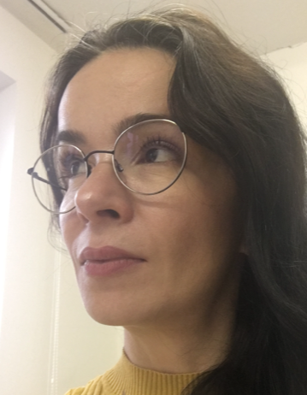
Affiliation: Institute of Applied Biotechnologis a.s., Prague, Czech Republic
Ph. No: +420 605 200 674
Email ID’s: kvapilova@iabio.eu
WhatsApp No: +420 605 200 674
Any alternative number:
Other Authors if any:
Pavol Misenko², Jan Radvanszky², Ondrej Brzon¹, Jaroslav Budis², Juraj Gazdarica², Ondrej Pos², Martin Kasny¹, Tomas Szemes², Petr Kvapil¹
1 Institute of Applied Biotechnologies a.s., Prague, Czech Republic
2 Geneton s.r.o., Bratislava, Slovak Republic
Presentation type: Oral presentation
Whole exome sequencing (WES) and whole genome sequencing (WGS) are standards in human clinical diagnostics and population genomics. First, we validated WGS and WES protocols by repeated sequencing and analysis of the NIST standard Coriell NA12878. NA12878 data calls were compared to the truth dataset published by the Genome in a Bottle Consortium. Subsequently we evaluated the quality and genotype concordance of single nucleotide variants (SNVs) and small insertions/deletions (indels) in the data sets. A paired comparison of blood-derived gDNA and saliva-derived gDNA was performed for SNVs and indels for both, WES and WGS using reference-validated protocols. The level of genotype concordance was also studied using ACMG SF v 3.2. gene set in two settings: exonic regions only/complete genes. The F1 score of ten paired blood-saliva samples range between 0.8030-0.9998 for SNVs and between 0.8883-0.9991 for indels in the WGS, and between 0.8643-0.999 for SNVs and between 0.7781-1.000 for indels in WES. The average values of SNVs variant calls concordance in ACMG SF gene set were 98.73 % for WGS, 99.81 % for WGS restricted to exonic regions only and 99.54 % for WES. Concordance of indels calls reach on average 92.88 % for WGS samples, 97.77 % for exonic regions in WGS and 70.51 % for WES. The quality pattern of called variants obtained from genomic-reference-based technical replicates correlates with data calls of paired blood–saliva-derived samples in all levels of tested examinations. The resulting data shows a clear advantage of the WGS approach over WES; especially for indels analysis while confirming no significant differences between blood and saliva samples.
Biography
I believe in the power of precise thinking, logical arguments, and principles. That's why our team and I focused on a comparative study that provides solid arguments for the use of saliva in clinical diagnostics.
As a graduate molecular biologist, I can see what great progress has been made in the last 5 years, not only in the field of sequencing but also in the bioinformatics processing of sequencing data as well as the implementation of AI in clinical diagnostics. I have been working at the Institute of Applied Biotechnology for five years, where I see the sense in making sequencing technology available to users of biological sciences as well as to clinicians.

