Unveiling phenotypic diversity in Kabuki syndrome: Missense variants underlie new entities
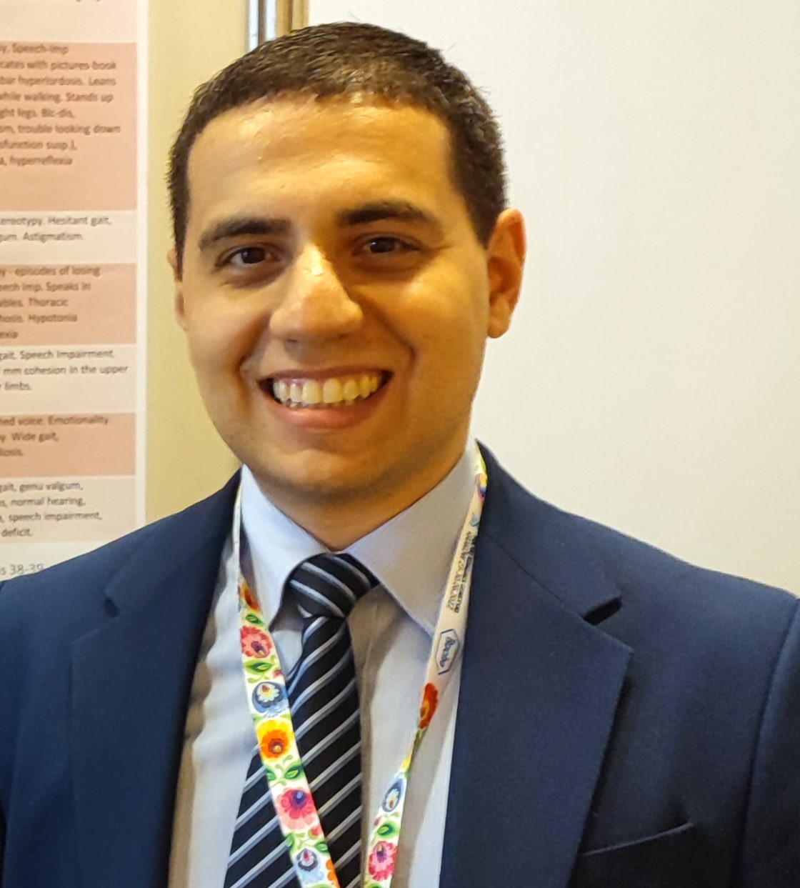
Corresponding Author name: Snir Boniel, MD.
Affiliation: Department of Medical Genetics, Medical University of Warsaw, Poland.
Ph. No: +48 794 421 022
Email ID’s: snir.boniel@wum.edu.pl; snir.boniel@yahoo.com
WhatsApp No: +48 794 421 022
Other Authors if any: Krystyna Szymanska MD, PhD; Aneta Jeziorek, MD; Magdalena Zarlenga, MD; Katarzyna Krenke MD, PhD; Anna Majcher, MD, PhD; Beata Pyrżak MD, PhD; Krzysztof Szczaluba MD, PhD.
Presentation type: (Oral presentation/ Poster presentation)
Abstract:
Kabuki Syndrome (KS) patients present a complex clinical landscape characterized by distinctive facial dysmorphism, developmental delay, and well characterized multisystemic manifestations. Truncating KMT2D gene mutations have been identified as the most common etiology of KS, however a subset of cases harbors missense variants, illuminating a nuanced spectrum of phenotypic expression. These cause reduced histone methylation and have been identified along the length of the KMT2D gene.
Recent investigations have spotlighted specific missense mutations within exons 38 and 39 of KMT2D, delineating a severe phenotype marked by profound dysmorphism and congenital anomalies. Contrarily, missense variants closer to the C-terminus, notably between exons 46 to 52 unveil a milder clinical trajectory, accompanied by unique phenotypic signatures and distinct behavioral traits.
We present a series of KS patients harboring confirmed KMT2D missense mutations. We elucidate a diverse array of clinical manifestations, some extending beyond those previously described in literature. Patients exhibited milder dysmorphism, abnormal dentition and unique behaviors (musicality, stereotypies, and emotionality), enriching the clinical narrative of KS. Moreover, our findings underscore a correlation between the location of missense variants and the phenotypic trajectory, with variants proximal to the C-terminus portending a milder clinical course compared to counterparts with truncating mutations or a missense variant in exons 38 to 39.
This study not only broadens the phenotypic spectrum of KS but also underscores the imperative for individualized therapeutic strategies tailored to the specific genetic landscape of affected individuals. Unraveling the intricate interplay between genotype and phenotype may pave the way for personalized interventions aimed at ameliorating the clinical burden of KS and enhancing patient outcomes in the future.
Biography:
Dr. Snir Boniel, MD, is a graduate of the Medical University of Warsaw, where he earned his medical degree. Currently practicing medicine at the Medical University of Warsaw Clinical Hospital, Dr. Boniel brings a wealth of experience to his role. With a steadfast dedication to the field of medical genetics, he has been closely affiliated to the Department of Medical Genetics at the Medical University of Warsaw for over six years, concurrently pursuing his doctoral studies.
Fluent in five languages, Dr. Boniel embraces his identity as a global citizen, reflecting his upbringing in Warsaw, Poland, and his connections to family around the world. Renowned for his meticulous approach and unwavering professionalism, he continuously strives for excellence in patient care and service, leveraging his extensive knowledge and commitment to lifelong learning.
Beyond medicine, Dr. Boniel finds solace and joy in jazz music, showcasing his art on the piano and trumpet. His multifaceted pursuits exemplify a holistic approach to life, blending academic rigor with creative expression. Dr. Boniel embodies the ethos of a diligent scholar, a compassionate healer, and a dedicated musician, enriching both the medical community and the world at large.

