Sample Abstract Guidelines:

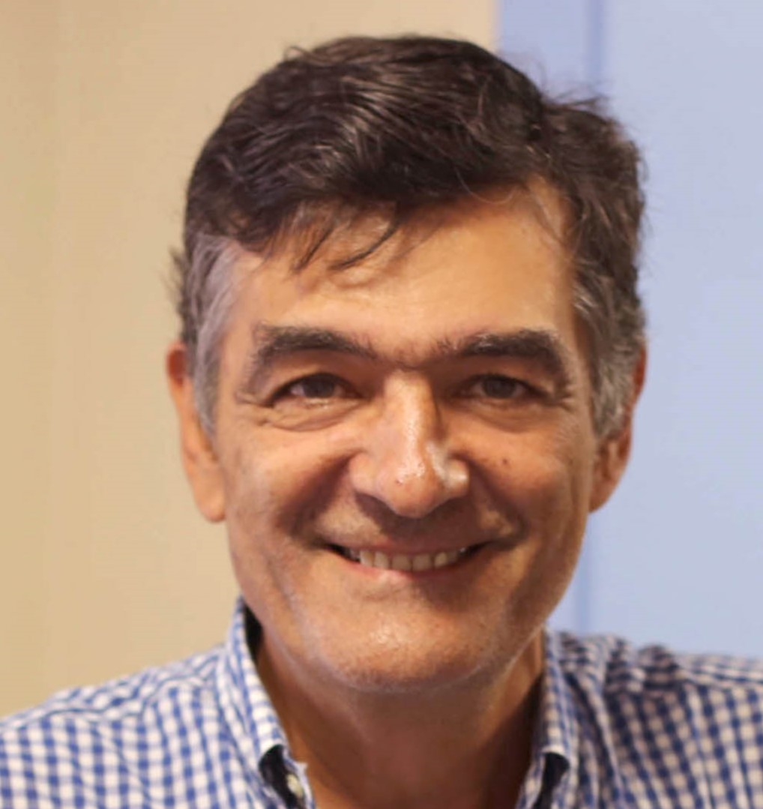
Presentation title: PRECISION MEDICINE TROUGH NGS IN A REFERENCE CENTER FOR RARE DISEASES: THE CASE OF THE NATIONAL INSTITUTE FERNANDES FIGUEIRA (FIOCRUZ/MS) IN THE STATE OF RIO DE JANEIRO, BRAZIL
Corresponding Author name: Juan Llerena Jr
Affiliation: Medical Genetic Center – National Institute Fernandes Figueira – Fiocruz – Rio de Janeiro, Brazil
Ph. No: +5521994392166
Email ID’s: juan.llerena@fiocruz.br; llerena52@gmail.com
WhatsApp No: +5521994392166
Any alternative number: -
Other Authors if any: Natana Rabelo, Maria Eduarda Gomes, Bianca Abdala, Sayonara Gonzalez,
Presentation type: Oral presentation
Abstract (250-300 words):
The Rare Disease Reference Center in the state of Rio de Janeiro, Brazil. OBJECTIVE: Reporting 285 molecular investigation for atypical clinical presentations, rare syndromes and/or syndromes with clinical/genetic heterogeneity. METHODS: Patients were investigated through Sanger gene targeted and/or customized gene panel (6,700 genes) Trusight One Expanded (Illumina) and/or Whole Exome Sequencing protocols. RESULTS: Overall, 270 patients received a definitive diagnosis. Clinical-molecular experiences exceeded our expectations exploring different scenarios: (1) rare syndromes - Salla disease(SLC17A5), Fuhrmann/Al-Awadi/Raas-Rothschild/Schinzel syndrome (WNT7A), glomuvenous disease (GLMN), Ullrich muscular dystrophy (COL6A3), Cantú syndrome (ABCC9), AR degenerative vitreoretinopathy (LRP5), muscular dystrophy dystroglycanopathy type C (FKTN), leukodystrophy with calcifications and multiple strokes (COL4A1), among others; (2) change in clinical management - suspected xeroderma pigmentosum that resulted in a syndrome with low tumor probability despite increased UV sensitivity(OMIM 614640)(UVSSA); (3) within the rasopathies: diagnostic switches - Noonan to Coffin-Siris (ARID1B); identification of a new variant (LZTR1); and, a case of double dominant heterozygote (PTPN11; NF1); (4) proposal of atypical mechanisms of inheritance - digenic inheritance in a familial Ellis Van Creveld phenotype in three siblings (DYNC2H1;C21orf2); McKusick CHH syndrome with glaucoma carrying a double recessive mutations (RMRP;CYP1B1); (5) gene reversion by somatic recombination in Fanconi anemia (Groups A,F and L); (6) solving technical artefacts from Sanger sequencing due to inadequate annealing of primers due to polymorphism (Tanatophoric I and Glomuvenous Disease); and, (7) different DNA tissue sources - from lung biopsy maintained in liquid nitrogen (alveolar capillary dysplasia negative for FOXF1, FOXC2 and FOXL1). CONCLUSION: The workflow dynamics among the clinical and genomic teams were essential at all stages for reaching a precise diagnostic performance and subsequently a proper genetic counseling.

Biography (150-200 words):
Dr. Juan Llerena Jr is a senior Consultant in Clinical Genetics and Director of the Medical Genetics Centre of National Institute Fernandes Figueira, Fiocruz (Rio de Janeiro, Brazil), a maternal-infantile unit of the Brazilian Ministry of Health Department.
Trained as a General Practitioner and Internal Medicine with special interests in the fields of dysmorphology and clinical/molecular cytogenetics. He has co-authored over 150 articles in peer-reviewed journals. More recently, became Director of The Reference Centre for Rare Diseases in Rio de Janeiro, Brazil. Coordinates outpatient clinics related to genetic syndromes, osteogenesis imperfecta, inborn errors of metabolism, and skeletal dysplasias. And supports Botafogo Footbal Club.

