Current Overview of Blepharocheilodontic Syndrome (BCD). A Case Report and Systematic Review.
Corresponding Author name: Ronald Roosevelt Ramos Montiel PhD
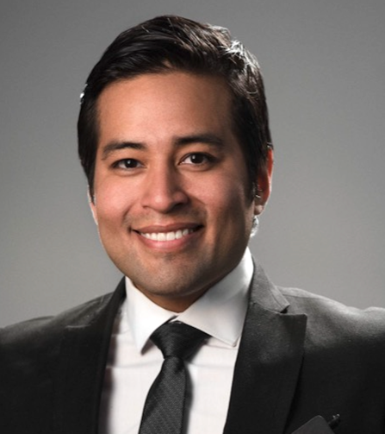
Affiliation: Catholic University of Cuenca
Ph. No: +593-0983528857
Email ID’s: ronald_mtz@hotmail.com – rramosm@ucacue.edu.ec
WhatsApp No: +593-0983528857
Other Authors if any:
- Estefanía Raquel Rodríguez Sanmartín
- David Alberto Delgado Acosta
- Hugo Xavier Guamán Roldán
- Celia María Pulgarin Fernández
Presentation type: (Oral presentation)
Abstract (250-300 words):
Introduction: Blepharocheilodontic syndrome is a rare autosomal dominant disorder characterized for craniofacial anomalies. Bilateral cleft lip/palate, dental agenesis and eyelid malformations are commonly present in individuals suffering this condition; nevertheless, hypothyroidism or glad agenesis, and imperforate anus frame in unusual phenotypic features. To date, about 60 cases have been reported. Objective: The purpose aim of this systematic review, is to create a current overview of blepharocheilodontic syndrome (BCD) throughout a case report. Methods: The protocol will be developed according to the Cochrane Handbook for Systematic Reviews of Interventions, and will be reported according to the Preferred Reporting Items for Systematic Reviews and Meta-Analysis (PRISMA) guidelines. Historical to date scientific data in general, will be obtained from PubMed, Medline, Embase, Researchgate, Lilacs, Proquest, Google Scholar, Epistemonikos, Springer, ScienceDirect, Scielo, Ovit, Taylor&Francis, Cochrane, Scientific Reports, Servicio de Descubrimiento de la UNA, Web of Science, Orphanet, ACPA, Dynamed, Dialnet, EBSPCO, and Webmd. The quality of evidence from the included documents might be assessed by Cochrane´s risk of bias tool. Data will be presented in summary results tables. This systematic review may report updated evidence of individuals suffering Blepharocheilodontic syndrome, thus including clinical and radiological features of the condition.
Biography (150-200 words):
Ronald Ramos has an Orthodontic Specialty. He obtained his doctorate at the age of 35 from the University of Zulia, Venezuela. He is currently an undergraduate professor in dentistry and coordinator of the specialization in orthodontics at the Catholic University of Cuenca. He is also editor-in-chief of the Multidisciplinary Graduate Journal and vice-president of the Orthodontic and Orthopaedic Society of Azuay-Ecuador.

