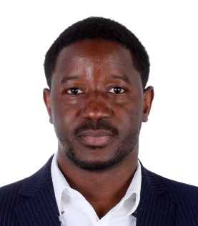
Abstract
Presentation title:
Assessment of Rare Earth Element Variations in Five Water Systems in Beijing: Distribution, Geochemical Features, and Fractionation Patterns
Corresponding Author Name: Dr. Mory Traore
Affiliation: School of Chemistry and Biological Engineering, University of Science and Technology Beijing, Beijing 100083, China.
I am currently working for Beijing Chaser Technology Co., Ltd.
Ph. No: +8615101635179
Email ID’s: b20190675@xs.ustb.edu.cn
WhatsApp No: +8615101635179
Any alternative number:
Other Authors, if any: Mory Traore, Min Zhang, Aijun Gong *, Yiwen Wang, Yang Liu a, b, Lina Qiu, Yuli Zhang, Yueyi You, Yuzhen Bai, Ge Gao, Weiyu Zhao, Mariame Traore, Mahamat Abderamane Hassan
Presentation type: (Oral presentation/ Poster presentation)
Abstract (250-300 words):
This study investigates the distribution of rare earth elements (REEs) within the Beijing water system, specifically examining the Yongding, Chaobai, Beiyun, Jiyun, and Daqing rivers. Results indicate that the Beiyun River exhibits the highest REE concentrations, ranging from 35.95 to 59.78 μg/mL, while the Daqing River shows the lowest concentrations, ranging from 15.79 to 17.48 μg/mL. LREEs (La to Nd) predominate with a total concentration of 23.501 μg/mL, leading to a notable LREE/HREE ratio of 7.901. Positive Ce anomalies (0.70-1.11) and strong positive Eu anomalies (1.38-2.49) were observed. The study suggests that the Beijing water system's REEs may originate from geological and anthropogenic sources, such as mining and industrial activities in neighbouring regions, including Inner Mongolia. These findings underscore the importance of ongoing monitoring and effective water management strategies to address REE-related environmental concerns.
Biography (150-200 words):
Mory Traore, Ph.D., is a distinguished chemist focusing on rare earth extraction and environmental chemistry. His expertise lies in developing innovative methods for rare earth extraction and separation and studying their environmental impact. Through his research, Mory aims to advance sustainable practices in resource utilization while addressing environmental challenges associated with pollutants and waste.

