Presentation title: INVESTIGATION OF THE COPPER SULFIDE THERMAL
DESTRUCTION PROCESS FROM FLOTATION TAILINGS
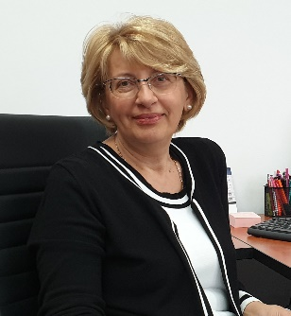
Corresponding Author name: Ljiljana Avramović
Affiliation: Technology and Metallurgy
Ph. No: +38130444147
Email ID’s: ljiljana.avramovic@irmbor.co.rs
WhatsApp No: +381637616578
Any alternative number:
Other Authors if any: Vanja Trifunović, Dragana Božić, Vesna Conić, Dejan Bugarin, Jelena Petrović, Vojka Gardić
Presentation type: (Oral presentation/ Poster presentation)
Abstract (250-300 words):
This paper presents the results of experimental tests on the thermal destruction of sulphide and leaching of copper from a sample of flotation tailings taken from the Old Flotation Tailing Dump (OFTD) of the Mining and Smelting Complex Bor (now Serbia Zijin Copper doo) in eastern Serbia. OFTD presents a typical example of a source of contamination through the acid mine drainage processes. The average copper content in the OFTD is about 0.2%, and the estimated amount of tailings amounts to 27 million tons, so it represents a significant potential raw material for copper recovery. Complete physico-chemical and mineralogical characterization of the composite tailings sample was performed, as well as the Leaching test and TCLP (Toxity Characteristic Leaching Procedure) test, which indicates that OFTD represents a significant environmental problem because it leads to the generation of acidic mine waters that pollute the surrounding waterways. Experimental tests included combined treatment: two-stage thermal treatment in a tubular furnace at temperatures of 250ºC and 630ºC in order to destroy copper sulfide from the flotation tailings, and leaching of the obtained calcine with water, during which a copper leaching rate of 92% was achieved. The solutions after leaching contain about 2 g/L Cu and less than 1 g/L Fe and are suitable for the application of the SX-EW (solvent extraction-electrowinning) process in order to obtain copper of commercial quality. A special advantage of the elaborated method is the possibility of disposing of the solid residue, formed after the process of thermal treatment and leaching of the tailings, without the risk of pollution of the human environment.

Biography (150-200 words):
Ph.D. Ljiljana Avramović, research associate, is employed at the Mining and Metallurgy Institute Bor, at the Center for Development Technologies in Metallurgy, currently in the position Head of Center. She is engaged in research, development and application of new technologies in the field of hydrometallurgical treatment of gold-bearing ores and concentrates; Obtaining and refining precious metals from primary and secondary raw materials; Development of technologies for copper recovery from mining waste; Participant of national, IPA and international projects in the field of environmental protection. She is the author or co-author of a large number of national and international papers.

