Abstract
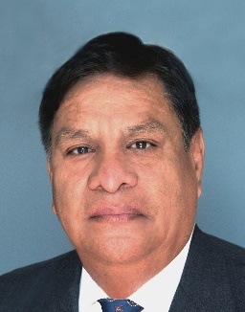
Presentation title: HERMETIC ELECTROCOAGULATION TECHNOLOGY FOR RECOVERY OF GOLD/SILVER AND SODIUM CYANIDE FROM PREGNANT CYANIDE SOLUTION
Corresponding Author name: Jose Refugio Parga Torres
Affiliation: Instituto Tecnológico de Saltillo - Tecnological nacional de Mexico, Saltillo, Coahuila, Mexico
Ph. No: +528442989077
Email ID’s: joserparga@gmail.com
WhatsApp No: +528442989077
Other Authors : Victor Vazquez Vazquez, and Nelson Oshogwue Etafo
Presentation type: (Oral presentation)
Abstract :
Gold and Silver are non-renewable resources and the consumption rates of the precious metals in various industrial and electronic purposes have been increasing continually, and resources of these metals have become more and more scarce over time in Mexico. The processes considered in this study are simultaneously recapturing gold and silver from the cyanidation process by electrocoagulation technology and by decreasing the pH at 8, injecting air into the electrolytical cell, and bubbling HCN _{(gas)} in sodium hydroxide solution we can regenerate the sodium cyanide. Electrocoagulation (EC), an emerging technology mainly used for wastewater treatment, was successfully applied for this achievement. This study will provide an introduction to the fundamental concepts of the EC method for recovering gold/silver metals from cyanide solutions. In this research X-ray Diffraction, Scanning Electronic Microscope and Atomic Adsorption were used to characterize the solid products formed during the EC process. The results suggest that magnetite particles and amorphous iron oxyhydroxides are present (Lepidocrocite and Gohetite). The EC products recover 97 % of gold and silver from pregnant cyanide solutions within 10 minutes and simultaneously the recovery of sodium cyanide was 95 % and recycled to the leaching process.
Biography:
Dr. José Refugio Parga Torres is a professor and is currently assigned to the graduate area of the Saltillo Technological Institute. Dr. Parga is a PhD graduate from the University of Utah and M.Sc. from Colorado school of mines. His work experience of 43 years is focused on the recovery of gold and silver using the flotation and smelting of non-ferrous metals and the care of the environment where he has contributed to innovative developments for the purification of water and recovery of toxic substances and precious metals contained in industrial effluents with 200 articles, 12 books, 12 patents, 50 research projects with industrial applications, and more than 6,400 citations. Dr. Parga has graduated 100 postdoctoral, doctoral, master, and engineering students, and 40 of them have won national and 5 international awards in Technological Innovation.

