Presentation Title: Analytical Profile of Immunity-Boosting Elements and Vitamins in Edible Indigenous Fruits found in Plateau State
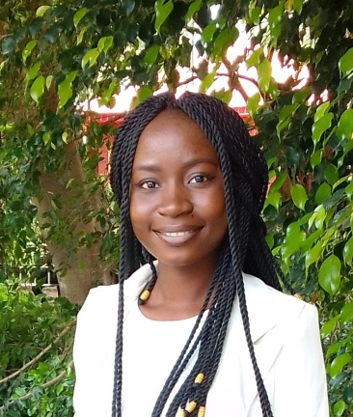
Corresponding Author name: Grace Michael Dalyop
Affiliation: Chemistry Department, University of Jos
Phone No: +2348136217332
Email ID’s: gracemichaeldalyop@gmail.com
WhatsApp No: +2348136217332
Any alternative number: +2348065359048
Other Authors if any: John S. Gushit
Presentation type: Oral presentation

Abstract:
Micronutrients known to boost immunity such as vitamin C, vitamin E, Zinc, Copper, Iron, and Selenium, must be adequately ingested for the immune system to function efficiently. Indigenous fruits in Plateau State, Nigeria, are rich sources of these micronutrients, yet many are underutilized due to limited awareness of their nutritional value. Eight indigenous fruits identified as Cola millenni K.Schum, Uvaria chamae P.Beauv, Annona senegalensis Pers., Dialium guineense Wild, Vitex doniana, Lanatana camara L., Mimusops elangi L., Coccocypselum aureum were analyzed for their immune-boosting potentials. The compositions of vitamin C, vitamin E and trace elements were determined using Iodometric Titration, High Performance Liquid Chromatography and Atomic Absorption Spectrometry respectively. Vitamin C levels ranged from 6.1741 to 294.0029mg/kg, with Dialium guineense showing the highest concentration. Vitamin E concentrations varied from 3.27 to 610.00mg/kg, with Vitex doniana and Dialium guineense exhibiting the highest levels. Zinc, Copper, Iron, and Selenium were found in notable concentrations across all fruits. Zinc concentrations ranged from 0.20 to 3.80mg/kg, with Mimusops elangi and Lantana camara having the highest values. Copper levels ranged from 5.60 to 43.60mg/kg, with Annona senegalensis and Lantana camara showing the highest concentrations. Iron concentrations varied from 0.60 to 3.40mg/kg, with Cola millenni and Lantana camara displaying the highest values. Selenium concentrations ranged from 4.60 to 30.20mg/kg, with Mimusops elangi recording the highest concentration. This research has highlighted the fruits' rich content of Vitamins C and E, particularly emphasizing Dialium guineense's potential for immune health. While all fruits contained immunity-boosting elements, Lantana camara and Mimusops elangi stood out for their higher trace element concentrations. Further studies on the essential micronutrients in the leaves, roots and barks of these fruits on the Plateau are needed to contribute to their nutritional significance and their potential in supporting immune health.
Biography
Grace, a successful lecturer, brings two years of invaluable research experience to her academic pursuits. With a Master's Degree in Analytical Chemistry, she is passionate about the intersection of science and societal well-being. Her research focuses on improving food safety and addressing malnutrition in her community. Through meticulous investigation, she identifies indigenous fruits rich in nutritional value, aiming to enhance immunity and alleviate malnutrition within her community and beyond. Her work embodies a harmonious blend of scientific rigor and social consciousness, reflecting a deep-seated commitment to enhancing public health outcomes. Grace is dedicated to identifying plants with significant nutritional benefits and developing innovative solutions to combat malnutrition and promote healthier lifestyles. Her dedication to research and teaching serves as a catalyst for positive change, inspiring her students to think critically about scientific knowledge and its practical applications. Grace's dedication to advancing knowledge and promoting community welfare exemplifies her status as a respected scholar and compassionate advocate for societal health and wellbeing.

