Sample Abstract Guidelines:

- Abstract Content should be in English
- The maximum word count should be 250-300 words
- If your title includes scientific notation, Greek letters, bold, italics, or other special characters/symbols, do make sure they appear correctly.
- Corresponding details of corresponding author should be correct which will be used for further communication.
- Abstracts should highlight the major points of your research and should not include tables, figures and references.
Format
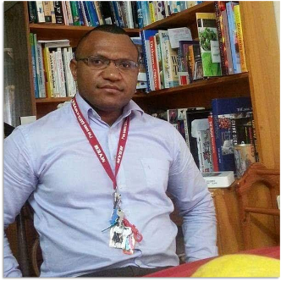
Presentation title: Copper contamination affects the biogeochemical cycling of nitrogen in freshwater sediment mesocosms.
Corresponding Author name: Tomson Tomoiye
Affiliation: WMW Laboratory, Port Moresby
Ph. No: +67573901564
Email ID’s: tomson.tomoiye@wmw.com.pg
WhatsApp No: +61451372751 / +67574000345
Any alternative number: +67574000345
Other Authors if any: Niklas Lehto and Leslie Huang (won’t be present)
Presentation type: (Oral presentation)
Abstract (250-300 words):
Trace elements can have a wide variety of effects on microbial populations and their function in the aquatic environment. However, specific impacts on chemical and biological processes are often difficult to unravel, due to the wide variety of chemical species involved and interactions between different elemental cycles. A replicated mesocosm experiment was used to test the effect of increasing copper concentrations, i.e., from 6 mg kg⁻¹ to 30 and 120 mg kg⁻¹, on nitrogen cycling in a freshwater sediment under laboratory conditions. Nitrous oxide emissions from the treated sediments were measured over three consecutive 24 h periods. This was followed by measurements of iron, manganese, copper and mineral nitrogen species (nitrate and ammonium) mobilization in the sediments using the diffusive gradients in thin films (DGT) and diffusive equilibria in thin films (DET) techniques and sequential extractions. Increasing copper concentrations are shown to have resulted in significantly reduced nitrate formation near the sediment–water interface and increased nitrous oxide emissions from the sediment overall. The concomitant mobilization and sequestration of iron with ammonium in the sediment with the highest Cu treatment strongly imply links between the biogeochemical cycles of the two elements. Modest Cu contamination was shown to affect the nitrogen cycle in the tested freshwater sediment, which suggests that even relatively small loads of the metal in fresh watercourses can exert an influence on nutrient loads and greenhouse gas emissions from these environments.

Biography (150-200 words):
Mr Tomoiye has expertise in chemistry and environmental science. With over 10 years experience of laboratory research work, Tomson developed the interest to focus his work more specifically on topics such as the mobilization of trace element in the environment and accumulation of greenhouse gases. Most of his work is done in the South Pacific Region including Australia and New Zealand. Tomson plans to do more work to help the Pacific Island Nations in the face of climate change. Tomson is also a part time environmental chemistry lecturer at the University of Papua New Guinea.

