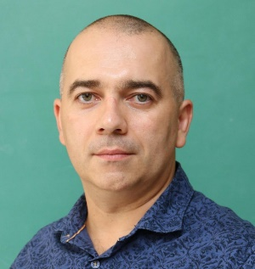
Presentation title: Acid-free Dissolution Recycling of Rare Earth Elements from the Diluted e-Waste Streams
Corresponding Author name: Dr. Denis Prodius
Affiliation: Critical Materials Innovation Hub, Ames National Laboratory (USDOE)
Ph. No: (+1)515-294-3513
Email ID’s: prodiusd@ameslab.gov
WhatsApp No:
Any alternative number:
Other Authors if any:
Presentation type: (Oral presentation)
Abstract:
The strategic places occupied by rare earth elements (REE) are increasingly being identified because supply disruptions can have negative impacts on dependent technologies, including clean energy applications. Recycling rare earth elements from permanent magnets is one of the ways to mitigate the negative impacts and often requires the decision to either directly reuse the permanent magnets or recover the rare earths in the form of metals, oxides or salts. This presentation will focus on recovery of REEs via the acid-free dissolution recycling technology, developed in the Critical Materials Innovation Hub at Ames National Laboratory (USDOE). The acid-free dissolution process enables selective leaching of REEs from e-wastes (e.g., from the shredded hard disk drives) without pre-separating the magnet contents, making further recycling of other e-waste contents possible. Being acid-free, it offers some environmental benefits (Life Cycle Analysis) and has been shown to be economically feasible (Techno-Economic Analysis) to be deployed in the United States. Since the initial results that led to the development of the acid-free dissolution recycling technology were obtained in 2016, the technology has progressively been matured and is now being licensed for commercial practice. This presentation will feature some of the recent advancements and future directions of the technology, considering the criticality of rare earth elements.
Acknowledgements
This work was supported by the Critical Materials Innovation Hub funded by the US Department of Energy, Office of Energy Efficiency and Renewable Energy, Advanced Materials and Manufacturing Technologies Office. This work was also partially supported by the U.S. Department of Energy SBIR/STTR program (Phases I, II and IIB; Award# DE-SC0020766) in cooperation with industrial partner TdVib LLC (Boone, Iowa/USA).

Biography:
Denis Prodius (Ph.D. in Inorganic Chemistry) is a scientist with the Critical Materials Innovation Hub at Ames National Laboratory, with more than ten years of experience working in recycling, recovery, and separation of rare-earth metals from a wide range of chemically processed materials (oxides, ionic liquids, oxalates, swarfs, and electronic wastes). Prodius’ research resulted in the development of an original acid-free magnet recycling approach that enables the ‘green’ and efficient recycling of critical materials, including rare earths and cobalt, from waste materials. He is a recipient of the Ames Laboratory Inventor Incentive Awards 2015, 2017, 2018 (3), 2019 and 2023. He is also the recipient of three R&D 100 awards, one TechConnect Innovation award, and two Federal Laboratory Consortium Notable Technology awards. Before coming to the Ames Lab, he spent three years at Karlsruhe Institute of Technology (Germany) as an Alexander von Humboldt Fellow.

