Chemical composition and anti-pathogenic human bacteria activity of decayed cedarwood essential oil

Oussama CHAUIYAKH*, Elmostafa EL FAHIME, Samar AARABI, Oumaima NINICH, Abdelaziz CHAOUCH, Aziz ETTAHIR

Corresponding author: O CHAUIYAKH (Oussama.chauiyakh@gmail.com ), Mohammed V University in Rabat, Higher School of Technology, Materials, Energy and Acoustics Team, Rabat, Morocco.

ABSTRACT (250-300 words)

Background:Cedar holds a prominent position in the global market for aromatic and medicinal plants due to its prized essential oils and exceptional wood quality. It encompasses four main species: Cedrus atlantica Manetti, found in the cedar forests of Morocco and Algeria; Cedrus Libani London, representing Lebanon's cedar forests; the Himalayan cedar (Cedrus deodora London); and the Cyprus cedar (Cedrus brevifolia Henry). Research has highlighted the potency and therapeutic benefits of oils and extracts rich in secondary metabolites, showcasing notable antibacterial, antiviral, antifungal, anticancer, antioxidant, and cytotoxic properties.
Objective: The aim of this study is to explore the potential value of deteriorated cedarwood (Cedrus atlantica M) sourced from the cedar grove within Tazekka National Park in Taza, Morocco.
Methods: This research focuses on extracting essential oils from healthy wood, wood affected by two specific diseases, and a blend of these woods by hydrodistillation. The goal is to analyze their chemical compositions by GC/MS and investigate their antibacterial properties by successive dilution method.
Results: The extraction process resulted in a 1.2% yield from healthy wood, 0.7% from wood infested by Saboune, 0.35% from wood infested by M’jej, and 0.55% from the mixed sample. Himachalenes emerged as the primary compounds, with diepicedrene-1-oxide characterizing wood affected by both diseases and the majority of the mixed wood sample. The antibacterial efficacy was assessed against eight bacteria strains obtained from various systems in unwell patients, revealing diverse responses to different concentrations of the essential oils.

BIOGRAPHY (100-150 words)

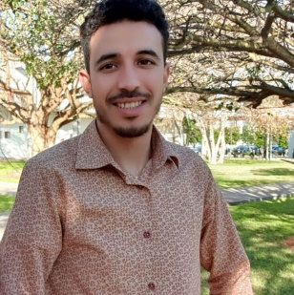
Oussama CHAUIYAKH, a 27-year-old doctor in Biology, affiliated with the Materials, Energy and Acoustics Team -EST Salé laboratory, reporting to the Sciences et Techniques pour l'Ingénieur doctoral study center of the Ecole Mohammedia d'Ingenieurs-Université Mohammed V de Rabat, with 10 SCOPUS-indexed scientific publications. Holder of a Master's degree in Engineering for the Valorization of Natural Resources and Quality Management in 2019, and a Bachelor's degree in Sciences and Techniques in Biomedical Technologies in 2016 and a Bachelor's degree in Life and Earth Sciences in 2013.
- Mobile Number*: 00212670864988
- Category*: Oral presentation
- Linked In
- WhatsApp No: (00212670864988)
- Research Interest*: Biotechnology, Medicinal biology
- Fax No:

