Title: New technique for sternal reconstruction with extensive bone loss

Authors: Yoandy López de la Cruz

Corresponding author: Yoandy López de la Cruz (yoandylc@infomed.sld.cu), Department of Cardiac Surgery, Santa Clara Cardiac Center. Villa Clara University of Medical Sciences. Cuba.

ABSTRACT

Background: Deep sternal wound infections are one of the most feared complications in cardiac surgery. Occasionally, the resulting osteomyelitis destroys much of the sternum, further complicating patient management. In highly developed countries, a large number of prostheses or substitutes are available to repair damaged bone; this does not happen in poorly developed countries. A patient is presented in whom a modification of the classic Robicsek technique allowed the total reconstruction of the severely damaged sternum.
Case report: 70 years old male patient undergoing coronary artery bypass grafting with bilateral internal thoracic artery. He developed a deep sternal wound infection that led to reoperation for debridement, mediastinal lavage, and placement of a povidone iodine irrigation system. He initially progressed favorably, but developed tracheitis with profuse cough that caused new instability of the sternotomy. In the second reoperation it was found that the steel wires had almost completely destroyed the right hemisternon and the cartilage of several ribs, bone segments that had to be completely removed.
Given the lack of a prosthetic substitute to treat this complication, it was decided to construct a "new" hemisternum by connecting the proximal segments of the fractured ribs with steel wires to each other and to a segment of the sternal manubrium that survived the destruction. Later, the new hemisternon was joined with the one on the left side (also reinforced with steel wires) with traditional figure 8 wire knots. The reconstruction was completed with flaps of both pectoral muscles. The patient progressed favorably in a short period of time with a magnificent aesthetic result.
Conclusion: To the best of our knowledge, this is the first report of the use of a modification of the classic Robicsek technique when there is no body of a hemisternum to support the lateral tension of the steel wires.

BIOGRAPHY

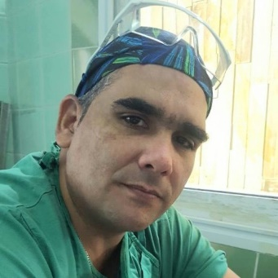
44 years old. Medical Doctor. Specialist in Family Medicine. Specialist in Cardiovascular Surgery. Master in Comprehensive Care for Women's Diseases. Ph.D. Associate Professor. Principal researcher. 17 years of experience in cardiovascular surgery. 60 articles published. More than 200 works presented at 50 national and international conferences. Full member of the Cuban Society of Cardiology and Cardiovascular Surgery. Full member of the Latin American Association of Cardiac and Endovascular Surgery (LACES). Head of the Surgical Unit of the Santa Clara Cardiac Center.
- Mobile Number: (+53) 53532125
- Category: Poster presentation
- WhatsApp No: (+53) 53532125
- Research Interest: Coronary Artery Disease, Coronary Artery Bypass Grafting, Internal Thoracic Artery.

