Title: Hybrid surgical procedure for simultaneous placement of epicardial and endovascular cardiac leads

Authors: Yoandy López de la Cruz, Yolepsis Quintero Fleites, Juan Miguel Cruz Elizundia

Corresponding author: Yoandy López de la Cruz (yoandylopezdelacruz@gmail.com), Department of Cardiac Surgery, Santa Clara Cardiac Center. Villa Clara University of Medical Sciences. Cuba.

ABSTRACT

Background: The treatment of heart failure due to dilated cardiomyopathy of unknown etiology is a challenge for current cardiology. Cardiac resynchronization therapy is an option to prolong the life of these patients. In very rare cases, a patient requires surgical procedures for the replacement of an old implantable cardioverter-defibrillator and the placement of a new cardiac resynchronization device. In these cases, a hybrid procedure can be performed for simultaneous placement of endocavitary and epicardial leads.
Case report: 54-year-old male patient; with a history of heart failure and placement of an implantable cardioverter-defibrillator (ICD) ten years earlier. A month earlier he received a closed chest trauma over the ICD pocket with hematoma formation and presence of local signs of infection for which he received treatment with antibiotics. At that time it was also decided to start cardiac resynchronization therapy, but the correct placement of the leads via endovascular route was not achieved. Cardiac surgeons decided to implement a "hybrid" strategy for the extraction of the old leads and placement, in a single surgical procedure, of the ICD leads (via endovascular) and the resynchronization device leads (epicardial).
Two surgical teams, synchronously, placed the leads of the ICD through the subclavian vessels and the lead of the resynchronization device in the lateral wall of the left ventricle through a median longitudinal sternotomy, which also allowed the opening of the heart for the extraction of the old leads. The surgical procedure was performed without complications and the patient progressed satisfactorily.
Conclusion: To the best of our knowledge, this is the first report of simultaneous placement of endovascular and epicardial leads using open surgical procedures in a conventional operating room (without radiological support). The strategy used avoided the need for two isolated surgical procedures, shortened the patient's hospital stay, and decreased medical care costs.

BIOGRAPHY

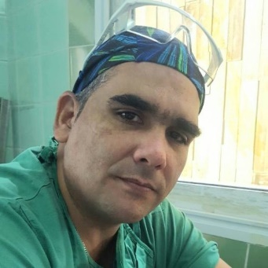
44 years old. Medical Doctor. Specialist in Family Medicine. Specialist in Cardiovascular Surgery. Master in Comprehensive Care for Women's Diseases. Ph.D. Associate Professor. Principal researcher. 17 years of experience in cardiovascular surgery. 60 articles published. More than 200 works presented at 50 national and international conferences. Full member of the Cuban Society of Cardiology and Cardiovascular Surgery. Full member of the Latin American Association of Cardiac and Endovascular Surgery (LACES). Head of the Surgical Unit of the Santa Clara Cardiac Center.
- Mobile Number: (+53) 53532125
- Category: Poster presentation
- WhatsApp No: (+53) 53532125
- Research Interest: Coronary Artery Disease, Coronary Artery Bypass Grafting, Internal Thoracic Artery.

