Title: The Association between COVID-19 and Risk of Hypertension among Afghan Participants:

Ubaidullah Niazi¹, Hasamudin Sayedi², Abu Zar Shinwari³, Rasool Khan Hayat⁴, Abdul Rafey⁵
¹Laboratory department, Spinghar Institute of Higher Education, Afghanistan
²Department of Biotechnology, Spinghar Institute of Higher Education, Afghanistan
³Department of Business Administration and Economics, Spinghar Institute of Higher Education, Afghanistan
⁴Department of Molecular Biology, Afghan Japan Hospital, Afghanistan
⁵Department of Molecular Biology, City Health Hospital, Afghanistan

Corresponding author: Ubaidullah Niazi (research@spingharkabul.edu.af) Member of the Research Department, Spinghar Institute of Higher Education (SIHE), Kabul, Afghanistan.

ABSTRACT (250-300 words)

Background: Blood pressure normally rises and falls throughout the day, but it can damage your heart and cause health problems if it stays high for a long time a study explained that hypertension with COVID-19 was significantly and more likely to have essential comorbidities and mortality in old ages. It is recommended to COVID-19 old patients to stay normal not to worry about the infection which they have that their blood pressure level stays normal.
Objective: To investigate the Severity of hypertension Due to the risk of COVID-19, and to know about Comorbidity and Mortality rate in Hypertension patients with SARS-CoV-2.
Methods: A quantitative descriptive research design has been used to analyze the primary data collected from the hospital. The data has been collected from 98 hospitalized patients from two government and private hospitals (Adie Medical Teaching Complex (AMTI) and Afghan Japan is a government hospital). The formal letters have been written to both hospitals to collect data in Hard copy after we added them to the Excel sheet and analyzed in SPSS
Results: The study population consisted of 98 adult hypertension patients with COVID-19 infections. Our analysis demonstrated that of these 98 hospitalized patients 65 (65.31%) were male and 33 (34.69%) were females. Our research revealed that 29.6% of participants had primary hypertension. The 66.3% and 4.1% of the population had secondary and pro-hypertension. The table shows that (96.9%) of patients had a cough and only (3.1%) didn’t have a cough while having COVID-19 and hypertension.
Conclusion: Hypertension with COVID-19 was significantly and more likely to have essential comorbidities and mortality in old age. it is recommended that COVID-19 patients stay normal and not worry about the infection, which they have their blood pressure level stays normal.

BIOGRAPHY (100-150 words)

I am Ubaidullah Niazi from Afghanistan, I was teaching in school. I have taught for five years in different schools and institutes in 2017. I have practical work in the Medical Diagnosis Lab Using, Cleaning, and Maintenance of Analyzers, for Chemical Analysis, Microscopic, Serology, Hematology, and Molecular Biology Departments for Three Years. I have research experiences such as data collection, data analysis, and reporting. I have already five research articles in medicine which have been published in national and International Journals Recently I have been the Head of the medical laboratory at Spinghar Medical University and a member of the Research Department at the University. I have attended different Workshops and seminars inside University and outside of University. I have presented the poster presentation at the 12th FMIC annual conference in 2022.
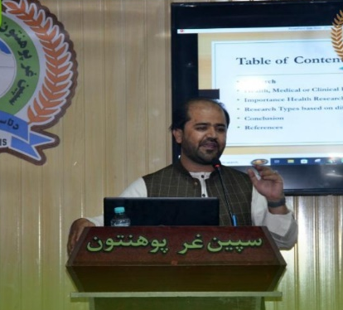
- Mobile Number*: +93795609690
- Category*: (Oral presentation)
- Linked In:
- WhatsApp No: (+93795609690)
- Research Interest*: Medical Science
- Fax No:

