Title: Impacts of SARS-CoV-2 infection on diabetic patients
(Afghan Japan Communicable Diseases Hospital, Kabul Afghanistan)
Rasool Khan Hayat ⁽¹⁾ Shahid Ullah Zadran ⁽²⁾ Abu Zar Shinwari ⁽³⁾ Abdul Rafey Popalzai ⁽⁴⁾ Ubaidullah Niazi ⁽⁵⁾
⁽¹⁾ Department of Molecular Biology, Afghan Japan Communicable Diseases Hospital, Research Directorate, Spinghar Institute of Higher Education (SIHE), Kabul Afghanistan.
⁽²⁾ Assistant Professor, Faculty of Biology, Kabul University, Afghanistan.
⁽³⁾ Master of Business Administration, Bakhtar University, Kabul Afghanistan.
⁽⁴⁾ Faculty of Medical Technology Spinghar Institute of Higher Education (SIHE), Kabul Afghanistan.
⁽⁵⁾ Head of Laboratory Department, Spinghar Institute of Higher Education (SIHE), Kabul Afghanistan.

Corresponding author: Rasool Khan Hayat (resrearch@spingharkabul.edu.af ), Member at Medicon open access Journals, Research Directorate (SIHE), Kabul, Afghanistan.

ABSTRACT (250-300 words)

Background: The present pandemic of SARS-CoV-2 coronavirus disease 2019 (COVID-19) is a serious challenge to Diabetes patients. Such patients may experience mild to more severe illnesses, organ failures, comorbidities, and a high risk of mortality due to pulmonary and cardiac involvement. This study was carried out to investigate the effects of COVID-19 on patients with Diabetes admitted to Afghan Japan Communicable Disease Hospital, Kabul, Afghanistan 2022.
Objective: To examine the Comorbidity in Mortality in Diabetes patients infected with SARS-CoV-2.
Methods: The medical records of 102 patients who were hospitalized due to COVID-19 from March to July 2021 admitted patients in HDU, ICU. Data was collected on Diabetes status, Comorbid conditions, and Laboratory COVID-19-detected RT-PCR Results. The data was analyzed using SPSS 20 (IBM).
Results: The data analyzed shows (56.86%) were male with diabetes and (43.14%) were female, and (70%) of patients had aged more than 50 years. The mortality rate was much higher than expectations (49%). The most common complications reported in diabetic patients who died of COVID-19 were Acute Respiratory Distress Syndrome ARDS (82%), Cardiac Pulmonary Arrest (CPA) (82%), Pneumonia (70%), Respiratory Failure (54%), Sepsis (46%), and Chronic obstructive pulmonary disease (COPD) (6%).
Conclusion: Diabetic patients who are infected with SARS-CoV-2 are at higher risk of mortality. Our findings suggested that diabetes did not significantly impact the prognosis of COVID-19 patients but negatively affected their clinical course. Further actions should be taken to make a significant step forward in the care of Diabetes patients. Research is needed to find the molecular changes that occur in expression level which leads to serious complications in diabetic patients who are infected with SARS-CoV2.
Key Words: SARS-COV-2, Diabetes, Comorbidity, Mortality

BIOGRAPHY (100-150 words)

I have about Ten years of Experience in the Medical Diagnostic Department. I am professionally trained with a degree in Medical Laboratory Technology. I am competent in laboratory equipment using, accuracy, Q.C, maintenance, and related computer technology to determine the health of patients. I have extensive knowledge from sample collecting to Analysis of Routine investigations in the PCR department I have actively contributed to the generation of accurate data to diagnose the problem.
I have Basic Research experience in Research methodology, writing articles, Data Collection, and Analysis, recently completed Four research articles that have already been published in National and International Journals.
Also, I have Experience Teaching, Medical Laboratory Faculty Students as a lecturer and Practical Classes at (SIHE). And now I'm ready to Start My MSc Degree Soon Inshallah.
I will make a good contribution to the work of the project in promoting good health.

Best Regards:
Rasool Khan Hayat

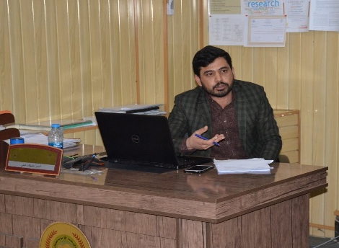
- Mobile Number*: +93-702054381
- Category*: (Poster presentation)
- Linked in: Rasool khan
- WhatsApp No: (+93702054381)
- Research Interest*: Epidemiology and Molecular Level
- Fax No?

