Abstract

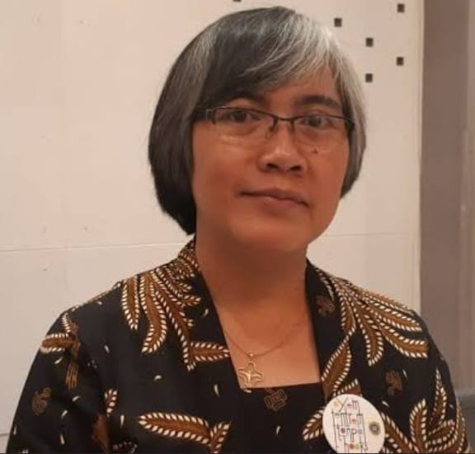
Presentation title: Personal Data and Privacy Violation as New Argument for the Stronger and Broader Rights-Based Partnership in Tobacco Control
Corresponding Author name: Valentina Sri Wijiyati
Affiliation: Jogja Sehat Tanpa Tembakau (JSTT)
Ph. No: +6282138641299
Email ID’s: valen.wiji@gmail.com
WhatsApp No: +6282138641299
Any alternative number: +6282265468216
Twitter: @wijipantun
LinkedIn: Valentina Sri Wijiyati
Facebook: Valentina Wiji
Other Authors if any: NA
Presentation type: Oral presentation
Abstract:
Tobacco industry brings destructive effects on human rights. The latest trend shows the new wave of tobacco industry’s destructive effect which forms in the shape of e-cigarette. Several governments took necessary steps to regulate e-cig while many others slow in protecting the people. One of the e-cigarette producer is Philip Morris with its iQOS. Reuters reported in May 2018 that “…the iQOS holds another, less obvious advantage over regular smokes: the ability to harvest personal data about users’ smoking habits. …” The report reveals the new destroyed area by tobacco industry: personal data and privacy. This study aims to assess the tobacco industry move on personal data and privacy against tobacco control dynamic. This qualitative study uses rights-based approach to assess the reported move by Philip Morris before the dynamic of multi stakeholders’ partnership in the field of tobacco control. Rights-based approach emphasizes the vulnerable groups’ access, participation, control, and received benefit. In the analysis, this scope of human rights is applied in combination with the models of respect-protection-fulfillment of vulnerable group rights: affirmative action, specific allocation, and mainstreaming. Public policy advocacy framework and SDGs are added as analysis tool. This study found tobacco industry move related with personal data and privacy destroys the access, participation, control, and benefit aspects regarding the personal data and privacy. In term of public policy advocacy, the move demonstrates the worst impact toward the layer of public policy culture. In addition on the victims’ addiction and the suspected more severe negative impact on victims wellbeing, the move contributes to the potential failure in achieving the SDGs whereas the vulnerable groups will suffered the most. The situation calls broader and stronger partnership within tobacco control covering privacy and personal data protection stakeholders.
Key words: human rights, iQOS, personal data, privacy, addiction, tobacco control, partnership
Biography:
During her time in the field of civil society organizations since 2004, Valentina Sri Wijiyati conducted researches on human-rights-related themes whether it is research that part of public policy advocacy or part of project evaluation. She spent around nine years in public budget advocacy field. She also dedicates her time as community organizer, facilitator, trainer, evaluator, manuscript editor, and volunteer (at least for tobacco control, anti-disinformation work, person with disability rights advocacy, women rights advocacy, and elementary education). Her encounters with various vulnerable groups and her engagement with diverse human-rights-related issues enrich and sharpen her perspective that help her much in working with stakeholders. Her profile and track records made her once as member of Ethic Board of Yogyakarta Chapter of Independent Journalist Alliance. She left the position due to tobacco industry-related fund that received by the organization. She is breast cancer fighter since 2021 and shares her time to accompany fellow cancer fighters. She is member of Ethic Board of Mafindo (mafindo.or.id) 2023-2025.

